**Assignment 17.5**

**Write a map reduce program to design a custom counter to count number of people are affected with 'PULMONARY' disease and 'BRONCHITIS & ASTHMA' in the state 'CA'.**

**Driver:**

**Step 1:** Create the ENUM for counters.

Since we are counting 2 types of diagnosis ENUM will become the group and fields will become the counters.

**Step2:** getting counters and printing it.

In mapper I am using j.get Counter to get all jobs and using c1 and c2 to get the counters for asthma and pulmonary and printing it using sysout.

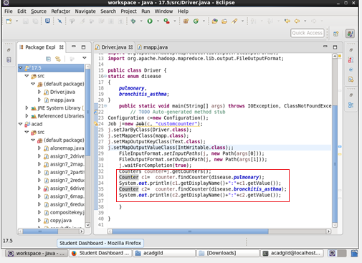

**Mapper:**

**Step1:** Splitting the value by comma as Delimiter

**Step2:** checking for pulmonary as disease and CA as state

**Step3:** Incrementing the counter

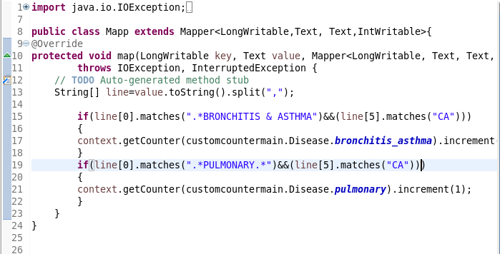

**Running JAR:**

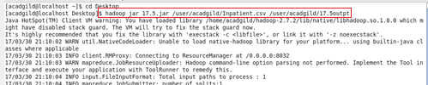

**OUTPUT:**

The custom counter and the count is displayed.

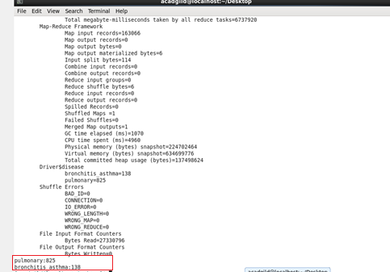

**JOB HISTORY SERVER:**

